10.21: From Eq. (10.11), the fraction of the total kinetic energy that is rotational is

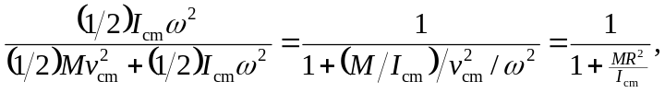
where 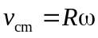 for an object that is rolling without slipping has been used.
a) so the above ratio is 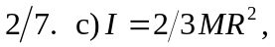 so the ratio is 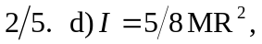 so the ratio is 